The following section is taken and modified from Algebra 2 Glencoe/McGraw – Hill 2001.

Introduction:
Consider a random sample of NBA basketball players.
Here is a frequency distribution table of such players’ heights.

Table
Heights | Frequency
78” | 2
79” | 3
80” | 6
81” | 15
82” | 9
83” | 4
84” | 1

The histogram above shows the distribution as a graph.

Curves are very useful to show a frequency distribution, especially when the distribution contains a large number of values. While the curves may be of any shape, many distributions have graphs shaped like the one below. Many distributions with this type of graph are normal distributions.

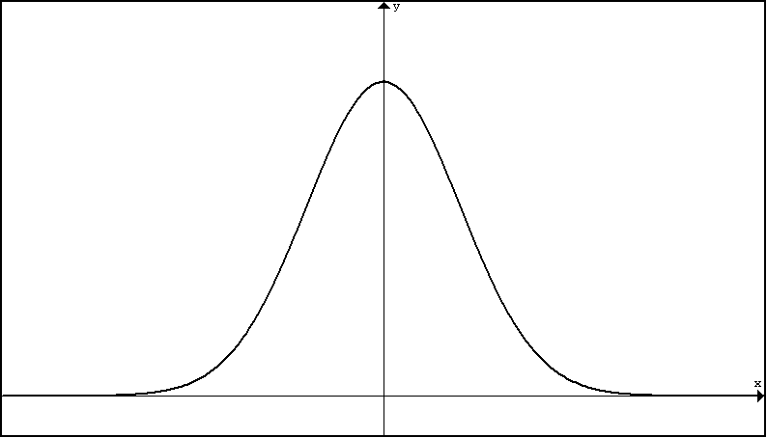

The curve of the graph of a normal distribution is symmetric and is often called a bell curve. The shape of the curve indicates that the frequencies in the normal distribution are concentrated around the center portion of the distribution.

Normal Curve Properties:
A true normal distribution has the following properties:
The graph is maximized at the mean .
The mean, median, and mode are all equal.
The data are symmetric about the mean.
68% of the values are within one standard deviation from the mean .
95% of the values are within two standard deviations from the mean.
99.7% of the values are within three standard deviations from the mean.

68%
50%
50%

95%
99.7%

Normal Curve Applications
Example 1: Suppose that the population of SAT math scores are normally distributed with a population mean of 500 and a population standard deviation of 90. Notice here that we assume that the population of scores is normally distributed.

A. Draw a normal curve graph to represent this distribution and label the scores at one, two and three standard deviations from the mean.

B. 68% of all the SAT math scores will fall between what two scores?

C. 95% of all the SAT math scores will fall between what two scores?

D. 99.7% of all the SAT math scores will fall between what two scores?

E. What percent of all SAT math scores will fall below 410?

F. What percent of all SAT math scores will fall between 500 and 590?

G. What percent of all SAT math scores will fall between 320 and 410?

H. Suppose 2000 students from a school district take the SAT.
i. Approximately how many will score more than 590?

ii. Approximately how many will score between 320 and 680?
Example 2: Let X be the lifetime of a battery. Suppose that the lifetimes of these batteries are normally distributed with a population mean of 20 hours and a population standard deviation of 4 hours.

A. Write the notation to describe the distribution.

B. Sketch a normal curve showing the life at one, two, and three standard deviations from the mean.

C. About how many batteries out of 10,000 will last between 16 and 28 hours?

D. About how many batteries out of 10,000 will last less than 12 hours?

Example 3: Let Y be the correct number of milligrams of anesthetic an anesthesiologist must administer to a patient is normally distributed with population mean 100 mg and population standard deviation 20 mg.

A. Write the notation to describe the distribution.

B. Sketch a normal curve showing the milligrams at one, two, and three standard deviations from the mean.

C. Of a sample of 200 patients, about how many people require more than 120 mg of anesthetic for a response?

D. What is the probability that a patient chosen at random will require between 80 and 120 mg?
Unusual Observations in Normally Distributed Data

In inferential statistics involving normal distributions, we often call an observation “unusual” if it falls about the extreme 5% of the data. In other words, the middle 95% of the data is considered usual while the outside 5% is considered unusual.

Example 1: Suppose that the population of SAT math scores are normally distributed with a population mean of 500 and a population standard deviation of 90. What SAT scores would be considered unusual?

Example 2: Let X be the lifetime of a battery. Suppose that the lifetimes of these batteries are normally distributed with mean 20 hours and standard deviation 4 hours. What battery lives would be considered unusual?

Example 3: Let Y be the correct number of milligrams of anesthetic an anesthesiologist must administer to a patient is normally distributed with mean 100 mg and standard deviation 20 mg. Would it be considered unusual for a patient to require 155 mg of anesthetic to obtain a response? Explain.

Z-Scores

A z – score refers to the number of standard deviation an observation falls from the mean.

Example 1: In the SAT example, a score of 590 is one standard deviation above the mean so we say z = +1. Likewise, a score of 230 is three standard deviation below the mean so z = -3 for this observation.
The following formula can be used to find the z-score of an observation.
So for x = 590:
And for x = 230:

A. How many standard deviations is the SAT score x = 620 from the mean?

B. How many standard deviations is the SAT score x = 160 from the mean?

C. What is the z-score associated with the SAT score x = 550?

D. What is the z-score associated with the SAT score x = 500 (the mean)?

Example 2:
A. How many standard deviations is a battery’s life if it lasts 30 hours?

B. What is the z-score associated with a battery life of 15 hours?

C. In terms of z-scores, what battery lives are considered unusual?

Example 3:
A. How many standard deviations is the milligrams dosage of 105 mg?

B. What is the z-score associated with a dosage of 54.5 mg?

C. Suppose a patient had a dosage with associated z – score z = -5.0. Comment on this patient.
Section 6: Practice Exercises

1. Consider a random variable X which is normally distributed with a population mean and population standard deviation. Sketch a normal curve for the distribution and label the x-axis at one, two, and three standard deviations from the mean.

2. Consider a random variable X which is normally distributed with a population mean and population standard deviation. Sketch a normal curve for the distribution and label the x-axis at one, two, and three standard deviations from the mean.

3. A set of data comes from a population that has a normal distribution with population mean and population standard deviation.
a. Find the percent of data within each interval.
i. between 4.2 and 5.1 iii. between 6.0 and 6.9 v. greater than 6.9
ii. between 4.2 and 6.0 iv. less than 4.2 vi. less than 5.1
b. Find the z-score associated with each observation
- x = 5.3
- x = 4.0
- x = 15.0
- x = 0

4. Scores on an exam are normally distributed with a population mean of 76 and a population standard deviation of 10.
- In a group of 230 tests, approximately how many students would you expect to score above 96?
- In a group of 230 tests, approximately how many students would you expect to score below 66?
- In a group of 230 tests, approximately how many students would you expect to score within one standard deviation of the mean?
- What test scores are considered unusual?

5. The lengths of a given nail type are normally distributed with a population mean length of 5.00 in. and a population standard deviation of 0.03 in.
- Find the expected number of nails in a bag of 120 that are less than 4.94 in. long
- Find the expected number of nails in a bag of 120 that are between 4.97 and 5.03 in. long.
- Find the expected number of nails in a bag of 120 that are over than 5.03 in. long.
- Would it be unusual to find a 4.9 in. nail in a package of this type? Explain.

